S3 Physics
Density and Kinetic Theory
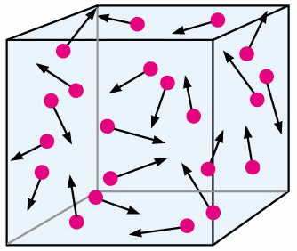

Pupil Booklet

- Learning Outcomes
- Homework
- Summary

SCN 4-08b
Through experimentation, I can explain floating and sinking in terms of the relative densities of different materials

SCN 4-05a
I have developed my understanding of the kinetic model of a gas. I can describe the qualitative relationships between pressure, volume and temperature of gases.

How Confident am I with the Content Statements?
- Circle the symbols to keep a record of your progress.
I am confident that I understand this and I can apply this to problems
I have some understanding but I need to revise this some more
I don’t know this or I need help because I don’t understand it

- You can use this to help you pick the areas of the unit that need the most revision.
- As you revise your class work you will be able to circle more and more smiley faces.
- If that does not help then you should ask your teacher!

Content Statements | Can you do this? | Comments
Density
1 To be able to explain, by looking at their densities, whether an object will float or sink in various liquids.
2 State that density is mass per unit volume of a substance.
3 To state that the units of density are grams per cubic centimeter (g/cm³).
4 Use the formula density =mass/volume to calculate the density of various objects.
5 To know how to measure the volume of a regular shaped solid.
6 To be able to describe how to measure the density of a regular shaped object.
7 To know how to measure the volume of an irregular shaped object.
8 To be able to describe how to measure the density of an irregular shaped object.
9 To be able to describe how to measure the density of a liquid.
10 To explain why different liquids separate when added together.
Kinetic Theory
11 To be able to identify a solid, liquid or gas by looking at a drawing of their particle arrangements.
12 To state that The Kinetic Theory of Gases describes a gas as a large number of small particles, all of which are in constant, random motion.
13 To state that the Kinetic Theory helps explain properties of gases such as volume, temperature and pressure.
14 To state that the pressure of a gas is caused by the particles colliding with the walls of the container that it is in.
15 To state that the temperature of a gas depends on the kinetic energy of the gas particles.
16 To state that the unit of Pressure is Pascals.
17 To state that as the volume of a fixed mass of gas increases, the pressure decreases provided the temperature of the gas remains constant (Boyle’s Law).
18 To be able to explain, with the aid of a diagram, why as the volume of a gas increases the pressure decreases provided that temperature remains constant.
19 To be able to use an Excel Spreadsheet to draw a graph.
20 To state that as the temperature of a gas increases the pressure increases provided the volume of the gas remains constant and that this is known as Gay Lussac’s Law.
21 To be able to explain why as the temperature increases the pressure of a gas increases provided the volume remains constant.

22 To state that as the volume of a gas increases the temperature increases provided the pressure of the gas remains constant and that this is known as Charles’ Law.
23 To be able to explain why as the temperature of a gas increases its volume increases provided the pressure of the gas remains constant.

Elective Homework – Getting Started

Success involves doing many kinds of problems which help improve your knowledge and understanding of the ideas in the course and your ability to solve problems. To get started we will look at a general method for tackling problems.

General Method for Solving Problems.

Any numerical problem in Physics can be solved using the following steps:

- Read the question carefully.
- Find out exactly what is being asked.
- Extract the key data.
- Select the correct equation.
- Substitute the data into the equation and find the missing variable.
- Give the answer and correct unit.

Example
How far does a cyclist travel in 26 seconds if she is travelling at a constant speed of 8 metres per second?

Solution

Read the question carefully

Find out exactly what is being asked Distance (how far)

Extract the key data time = 26 seconds
speed = 8 metres per second

Select the correct equation distance = speed x time
Substitute data into equation d = 8 x 26
Give the answer and correct unit d = 208 m

Usual Layout

d = ?  v = 8 m/s  t = 26 s | d = v x t  = 8 x 26  = 208 m

All numerical questions in the following homework exercises should be carried out in this way. No marks will be awarded for an answer given without the working being shown.

Helpful Hint

Always watch the units in an equation. They may need to be converted before being put into an equation.
e.g. 3 mA = 0.003 A = 3 x 10⁻³ A
6 km = 6000 m = 6 x 10³ m

Homework 1 – Density

- What is meant by the term density? (1)

- a) What is the formula for calculating density? (1)

b) What are the units of density? (1)

- A lump of iron has mass 49g and volume 7cm³. What is its density? (You must show your working). (2)

- The density of petrol is 0.7g/cm³. What mass of petrol is required to fill the petrol tank of a car which has a volume of 20 000cm³? (2)

- How does knowing the density of different materials help you to decide whether they will float or sink in the liquid that it is placed in? (1)

- Four liquids that do not mix are poured into a jar. The liquids separate into layers with the most dense liquid at the bottom as shown below.

The liquids and their densities are given in the table:
Liquid | Density (g/cm³)
Mercury | 13.6
Dibromoethane | 2.2
Paraffin | 0.8
Water | 1.0
a) Identify the liquids A, B, C and D (2)

b) A piece of copper of density 8.9g/cm³ is dropped into the jar. Draw out the diagram and mark with an X where the piece of copper will settle. (1)
Homework 1 Answers
(You will find help with this homework on pages 14 and 15)

Homework 2 – The Kinetic Theory and Boyle’s Law

1. Draw appropriate diagrams to show the particle arrangement for a solid, liquid and gas. (3)

2. a) State what is meant by the Kinetic Theory of Gases. (1)

b) Which properties of gases does the Kinetic Theory help explain? (1)

3. How does the Kinetic Theory explain the pressure exerted by a gas? (1)

4. What does the temperature of a gas depend on? (1)

5. What piece of apparatus can be used to measure the pressure of a gas? (1)

6. State Boyle’s Law, giving the two variables which must be kept constant. (2)

7. Which muscle in our bodies is a good example of Boyle’s Law in action? (You can only answer this question if you have read Appendix 1 in class). (1)

Homework 2 Answers
(You will find help with this homework on pages 16 and 17)

Homework 3 – The Gas Laws

1. Copy and complete the following statement which explains Gay Lussac’s Law:

As the ________________ of a gas increases the particles gain ___________ energy and move _________. They hit the walls of the container more often and with greater _________ thereby causing the pressure to ___________ (2)

2. After a car has been parked in the sun for some time, it is found that the pressure in the tyres has increased. Explain in terms of Gay Lussac’s Law why this has happened. (3)

3. Copy and complete the following statement which explains Charles’ Law:

As the _____________ of a gas increases, the particles gain __________ energy and move ________. The particles hit the walls of the container more often and with _________ force. The _________ must increase to give a greater surface area to keep the pressure constant. (2)

4. Give an example of how Charles’ law is put into action in every day life. (You can only answer this question if you have read Appendix 3) (1)

Homework 3 Answers
(You will find help with this homework on page 18)
Summary Notes

Density

Density is the mass per unit volume of a substance.

An object will float in the liquid it is placed in if it is less dense than that liquid and sink if it is more dense.

The formula used to calculate density is:

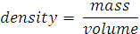

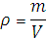

The units of density are grams per cubic centimetre (g/cm³)

To find the volume of a regular shaped object such as a cube or cuboid the following method is used:
Volume = length x breadth x height
= l x b x h

To find the density of any substance you must find its mass and volume then use the density formula.

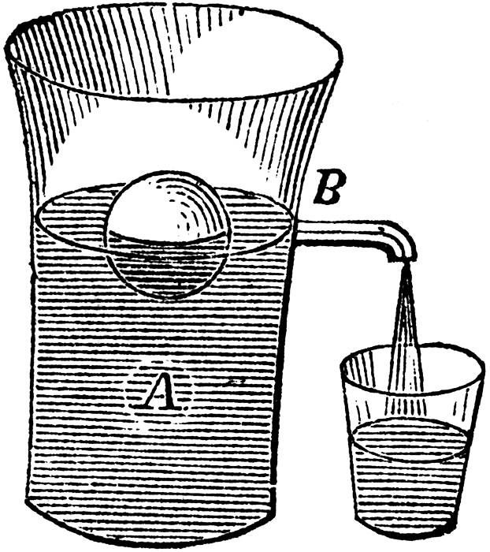
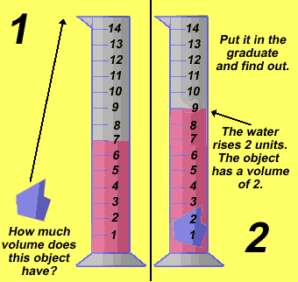
When liquids of different densities are added together in the one container they will separate out to form a density ladder. This is because the liquids are all different densities. The most dense liquid will go to the bottom and the least dense to the top. Where other objects sit in the density column depends on how dense the objects are.
Diagram 2
Diagram 1
To find the volume of an irregular shaped object the displacement of water is used, as illustrated in the diagrams below. Diagram 1 shows the water being displaced in a measuring cylinder and diagram 2 shows how an overflow vessel can be used.

Kinetic Theory
The following pictures represent the particle arrangement for solids, liquids and gases.

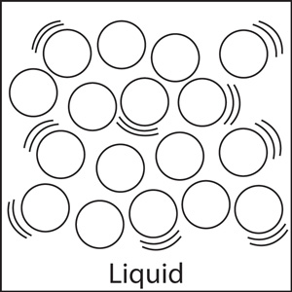
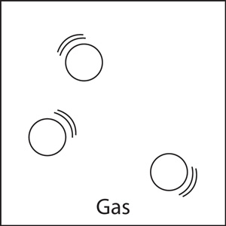
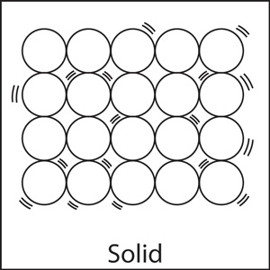

Temperature is measured in Degrees Celsius (◦C)
The temperature of a gas depends on the kinetic energy of the gas particles.
Pressure is measure in units called Pascals (Pa).
The pressure of a gas is caused by the particles colliding with the walls of the container it is in.
The Kinetic Theory of Gases describes a gas as a large number of small particles, all of which are in constant, random motion. It helps explain properties of gases such as volume, temperature and pressure.

A Bourdon Gauge is used to measure the pressure of a gas.

Gas Laws
There are three gas laws: Boyle’s Law, Gay Lussac’s Law and Charles’ Law.

Boyle’s Law explains that as the volume of a fixed mass of gas increases, the pressure decreases provided the temperature of the gas remains constant. This is because when the volume increases the particles move further apart and collide less frequently with the walls of the container. (See diagram below).

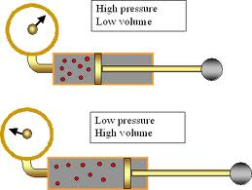

Boyle’s Law

Gay Lussac’s Law explains that as the temperature of a fixed mass of gas increases the pressure increases provided the volume remains constant. This is because as the temperature increases the particles gain kinetic energy and move faster. They collide with the walls of the container more often and with greater force, thereby causing the pressure to increase. (See diagram below).

Charles’ Law states that as the volume of a fixed mass of gas increases the temperature increases provided the pressure of the gas remains constant. This is because as the temperature increases the particles gain kinetic energy and move faster. They collide with the walls of the container more often and with greater force. The volume must increase to give a greater surface area to keep the pressure constant. (See diagram below).

Gay Lussac’s Law

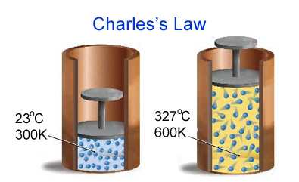

Charles’ Law
Gay Lussac’s Law

